Collection interview Question 1. What is Collection framework in java?

Answer. java.util.Collection is the root interface in the hierarchy of Java Collection framework in java.

The JDK does not provide any classes which directly implements this interface, but it provides classes which are implementations of more specific subinterfaces like Set and List in java.

java.util.Set extends java.util.Collection interface in java.
HashSet, CopyOnWriteArraySet, LinkedHashSet, TreeSet, ConcurrentSkipListSet, EnumSet classes implements Set interface.

java.util.List extends java.util.Collection interface in java.
ArrayList, LinkedList, Vector, CopyOnWriteArrayList classes implements List interface.

Collection interview Question 2. Which interfaces and classes are most frequently used in Collection framework in java?
Answer.
Most frequently used interface in Collection framework are >
List, Set and Map.

Most frequently used classes in Collection framework are >
HashSet, LinkedHashSet, TreeSet, ConcurrentSkipListSet classes implements Set interface.

ArrayList, LinkedList, Vector, CopyOnWriteArrayList classes implements List interface.

HashMap, Hashtable, ConcurrentHashMap, LinkedHashMap, TreeMap, ConcurrentSkipListMap classes implements Map interface.

Collection interview Question 3. What are subinterfaces of Collection interface in java? Is Map interface also a subinterface of Collection interface in java?

Answer. List and Set are subinterfaces of java.util.Collection in java.

It’s important to note Map interface is a member of the Java Collections Framework, but it does not implement Collection interface in java.

Collection interview Question 4. What are differences between ArrayList and LinkedList in java?
Answer. This is very important collection framework interview question in java.

 | Property | java.util.ArrayList | java.util.LinkedList
1 | Structure | java.util.ArrayList is index based structure in java.  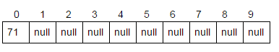 | A java.util.LinkedList is a data structure consisting of a group of nodes which together represent a sequence.  node is composed of a data and a reference (in other words, a link) to the next node in the sequence in java.  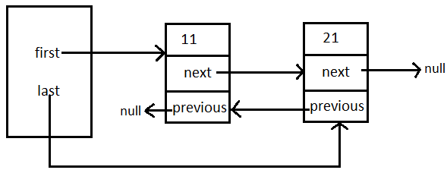
2 | Resizable | ArrayList is Resizable-array in java. | New node is created for storing new element in LinkedList in java.
3 | Initial capacity | java.util.ArrayList is created with initial capacity of 10 in java. | For storing every element node is created in LinkedList, so linkedList’s initial capacity is 0 in java.
4 | Ensuring Capacity/ resizing. | ArrayList is created with initial capacity of 10.  ArrayList’s size is increased by 50% i.e. after resizing it’s size become 15 in java. | For storing every element node is created, so linkedList’s initial capacity is 0, it’s size grow with addition of each and every element in java.
5 | RandomAccess interface | ArrayList implements RandomAccess(Marker interface) to indicate that they support fast random access (i.e. index based access) in java. | LinkedList does not implement RandomAccess interface in java.
6 | AbstractList and AbstractSequentialList | ArrayList extends AbstractList (abstract class) which provides implementation to List interface to minimize the effort required to implement this interface backed by RandomAccess interface. | LinkedList extends AbstractSequentialList (abstract class), AbstractSequentialList extends AbstractList.  In LinkedList, data is accessed sequentially, so for obtaining data at specific index, iteration is done on nodes sequentially in java.
7 | How get(index) method works?  (Though difference has been discussed briefly in above 2 points but in this in point we will figure difference in detail.) | Get method of ArrayList directly gets element on specified index. Hence, offering O(1) complexity in java. | Get method of LinkedList iterates on nodes sequentially to get element on specified index. Hence, offering O(n) complexity in java.
8 | When to use | Use ArrayList when get operations is more frequent than add and remove operations in java. | Use LinkedList when add and remove operations are more frequent than get operations in java.

Collection interview Question 5. What are differences between ArrayList and Vector in java ?
Answer. Another very important collection framework interview question to differentiate between ArrayList and Vector in java.

 | Property | java.util.ArrayList | java.util.Vector
1 | synchronization | java.util.ArrayList is not synchronized (because 2 threads on same ArrayList object can access it at same time).  I have created program to show consequence of using ArrayList in multithreading environment.  In the program we will implement our own arrayList in java. | java.util.Vector is synchronized (because 2 threads on same Vector object cannot access it at same time).  I have created program to show advantage of using Vector in multithreading environment.  In the program we will implement our own vector in java.
2 | Performance | ArrayList is not synchronized, hence its operations are faster as compared to Vector in java. | Vector is synchronized, hence its operations are slower as compared to ArrayList in java.  If we are working not working in multithreading environment jdk recommends us to use ArrayList.
3 | Enumeration | Enumeration is fail-fast, means any modification made to ArrayList during iteration using Enumeration will throw ConcurrentModificationException in java. | Enumeration is fail-safe, means any modification made to Vector during iteration using Enumeration don’t throw any exception in java.
4 | Introduced in which java version | ArrayList was introduced in second version of java i.e. JDK 2.0 | Vector was introduced in first version of java i.e. JDK 1.0  But it was refactored in java 2 i.e. JDK 1.2 to implement the List interface, hence making it a member of member of the Java Collections Framework.
5 | Ensuring Capacity/ resizing. | ArrayList is created with initial capacity of 10.  When its full size is increased by 50% i.e. after resizing it’s size become 15 in java. | Vector is created with initial capacity of 10.  Vector’s size is increased by 100% i.e. after resizing it’s size become 20 in java.
6 | Custom implementation | 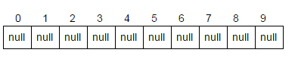Read : ArrayList custom implementation | Read :  Vector custom implementation

Collection interview Question 6. What are differences between List and Set interface in java?
Answer.

 | Property | java.util.List | java.util.Set
1 | Insertion order | java.util.List is ordered collection it maintain insertion order in java. | Most of the java.util.Set implementation does not maintain insertion order.  HashSet does not maintains insertion order in java.  Thought LinkedHashSet maintains insertion order in java.  TreeSet is sorted by natural order in java.
2 | Duplicate elements | List allows to store duplicate elements in java. | Set does not allow to store duplicate elements in java.
3 | Null keys | List allows to store many null keys in java. | Most of the Set implementations allow to add only one null in java.  TreeSet does not allow to add null in java.
4 | Getting element on specific index | List implementations provide get method to get element on specific index in java.  ArrayList, Vector, copyOnWriteArrayList and LinkedList provides -  get(int index)  Method returns element on specified index.  Get method directly gets element on specified index. Hence, offering O(1) complexity. | Set implementations does not provide any such get method to get element on specified index in java.
5 | Implementing classes | ArrayList, LinkedList, Vector, CopyOnWriteArrayList classes implements List interface in java. | HashSet, CopyOnWriteArraySet, LinkedHashSet, TreeSet, ConcurrentSkipListSet, EnumSet classes implements Set interface in java.
6 | listIterator | listIterator method returns listIterator to iterate over elements in List in java.  listIterator provides additional methods as compared to iterator like  hasPrevious(), previous(), nextIndex(), previousIndex(), add(E element), set(E element) | Set does not provide anything like listIterator. It simply return Iterator in java.
7 | Structure and resizable | List are Resizable-array implementation of the java.util.List interface in java. | Set uses Map for their implementation.  Hence, structure is map based and resizing depends on Map implementation.  Example > HashSet internally uses HashMap.
8 | Index based structure /RandomAccess | As ArrayList uses array for implementation it is index based structure, hence provides random access to elements.  But LinkedList is not indexed based structure in java. | Set is not index based structure at all in java.

Collection interview Question 7. What are differences between Iterator and ListIterator? in java
Answer. This collection framework interview question is tests your knowledge of iterating over different collection framework classes in java.

 | java.util.ListIterator | java.util.Iterator
1 | hasPrevious() method returns true if this listIterator has more elements when traversing the list in the reverse direction. | No such method in java.util.Iterator.
2 | previous() returns previous element in iteration (traversing in backward direction).  if the iteration has no previous elements than NoSuchElementException is thrown. | No such method in java.util.Iterator.
3 | nextIndex() method returns the index of the element that would be returned by a subsequent call to next() method. If listIterator is at the end of the list than method returns size of list. | No such method in java.util.Iterator.
4 | previousIndex() method returns the index of the element that would be returned by a subsequent call to previous() method. If listIterator is at the start of the list than method returns -1. | No such method in java.util.Iterator.
5 | add(E element)  Method inserts the specified element into the list.  The element is inserted immediately before the element that would be returned by next (So, subsequent call to next would be unaffected), if any, and after the element that would be returned by previous (So,subsequent call to previous would return the new element), if any.  If the list does not contain any element than new element will be the sole element in the list. | No such method in java.util.Iterator.
6 | set(E element)  Method replaces the last element returned by next() or previous() method with the specified element. This call can be made only if neither remove nor add have been called after the last call to next or previous.  If call to set() method is followed up by any call made to remove() or add() method after next() or previous() than UnsupportedOperationException is thrown. | No such method in java.util.Iterator.
7 | All the implementations of List interface like ArrayList, LinkedList, Vector, CopyOnWriteArrayList classes returns listIterator. | All Implementation classes of Collection interface’s subinterfaces like Set and List return iterator.

Collection interview Question 8. What are differences between Collection and Collections in java?
Answer.

java.util.Collection ​ is the root interface in the ​hierarchy of Java Collection framework​.
The JDK does not provide any classes which directly implements java.util.Collection interface, but it provides classes such as ArrayList, LinkedList, vector, HashSet, EnumSet, LinkedHashSet, TreeSet, CopyOnWriteArrayList, CopyOnWriteArraySet, ConcurrentSkipListSet which implements more specific subinterfaces like ​Set and List​ in java.

java.util.Collections is a utility class which consists of static methods that operate on or return Collection in java.

java.util.Collections provides method like >
- reverse method for reversing List in java.
- shuffle method for shuffling elements of List in java.
- unmodifiableCollection, unmodifiableSet, unmodifiableList, unmodifiableMap methods for making List, Set and Map unmodifiable in java.
- min method to return smallest element in Collection in java.
- max method to return smallest element in Collection.
- sort method for sorting List.
- synchronizedCollection, synchronizedSet, synchronizedList, synchronizedMap methods for synchronizing List, Set and Map respectively in java.

Collection interview Question 9. What are core classes and interfaces in java.util.List hierarchy in java?
Answer. Freshers must know core classes in List hierarchy but experienced developers must be able to explain this java.util.List hierarchy in detail.
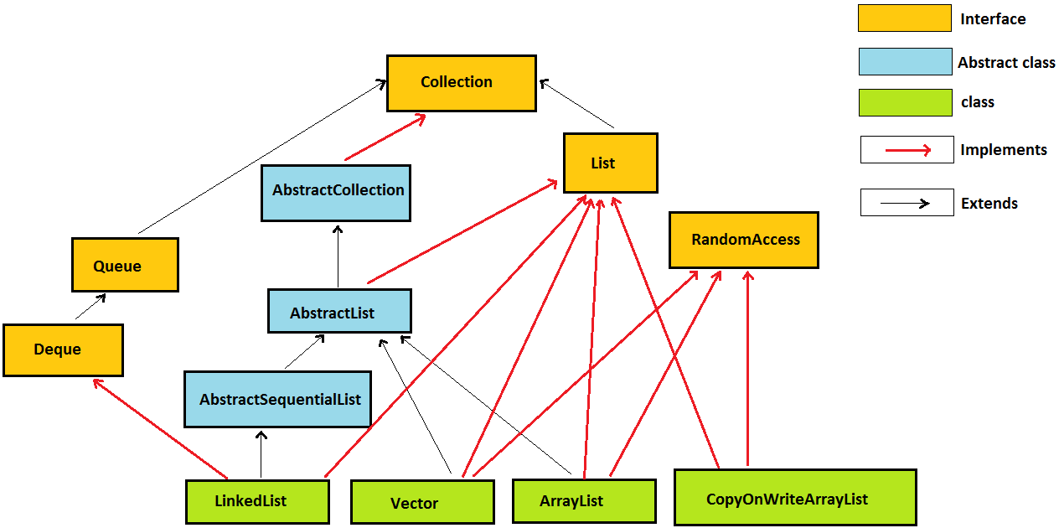

java.util.List interface extends java.util.Collection interface.

java.util.ArrayList, java.util.LinkedList, java.util.Vector, java.util.concurrent.CopyOnWriteArrayList classes implements java.util.List interface.

Also, some abstract classes like java.util.AbstractCollection, java.util.AbstractList and java.util.AbstractSequentialList have been mentioned in hierarchy.

Collection interview Question 10. What are core classes and interfaces in java.util.Set hierarchy?
Answer. Freshers must know core classes in Set hierarchy but experienced developers must be able to explain this java.util.Set hierarchy in detail.
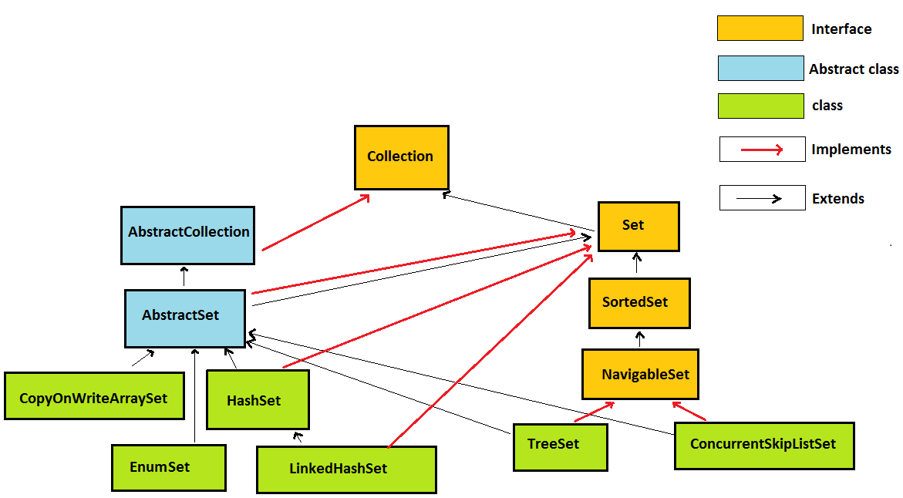
java.util.Set interface extends java.util.Collection interface.

java.util.HashSet, java.util.concurrent.CopyOnWriteArraySet, java.util.LinkedHashSet, java.util.TreeSet, java.util.concurrent.ConcurrentSkipListSet, java.util.EnumSet classes implements java.util.Set interface.

Also some abstract classes like java.util.Dictionary and java.util.AbstractSet and java.util.AbstractCollection have been mentioned in hierarchy.

Collection interview Question 11. What are core classes and interfaces in java.util.Map hierarchy?
Answer. Freshers must know core classes in Map hierarchy but experienced developers must be able to explain this java.util.Map hierarchy in detail.

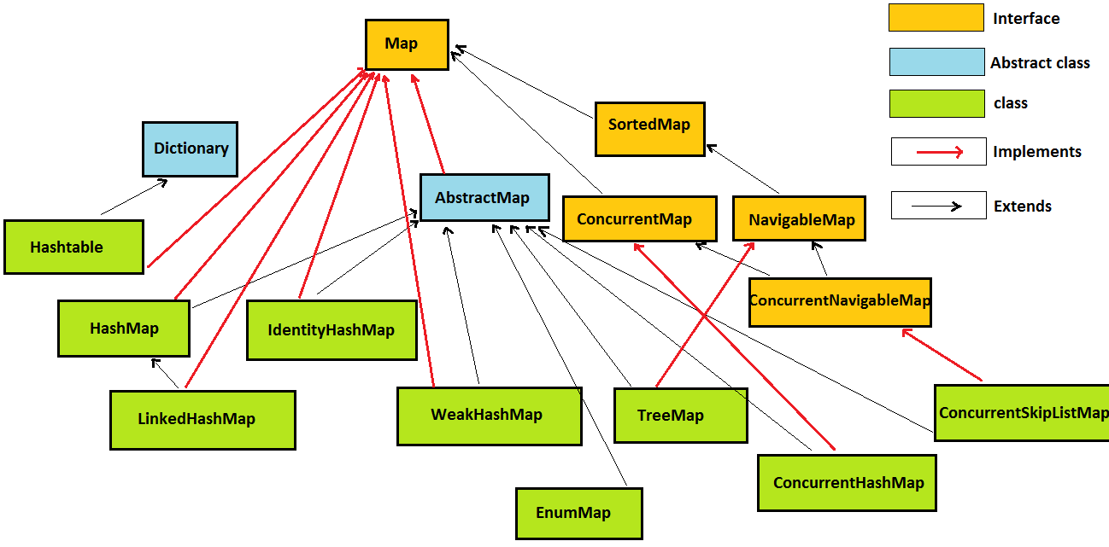

java.util.Map interface extends java.util.Collection interface.

java.util.HashMap, java.util.Hashtable, java.util.concurrent.ConcurrentHashMap, java.util.LinkedHashMap, java.util.TreeMap, java.util.concurrent.ConcurrentSkipListMap, java.util.IdentityHashMap, java.util.WeakHashMap, java.util.EnumMap classes implements java.util.Map interface.

Collection interview Question 12. What are differences between Iterator and Enumeration in java?
Answer. Experienced developers must be well versed to answer this collection framework interview question in java.

 | Property | java.util.Enumeration | java.util.Iterator
1 | Remove elements during iteration | java.util.Enumeration doesn’t allows to remove elements from collection during iteration in java. | java.util.Iterator allows to remove elements from collection during iteration by using remove() method in java.
2 | Improved naming conventions in Iterator | nextElement()  Method Returns the next element of this enumeration if this enumeration object has at least one more element to provide.  hasMoreElements()  returns true if enumeration contains more elements. | nextElement() has been changed to next() in Iterator.  And  hasMoreElements() has been changed to hasNext() in Iterator.
3 | Introduced in  which java  version | Enumeration was introduced in first version  of java i.e. ​JDK 1.0 | Iterator was introduced in second version  of java i.e. ​JDK 2.0  Iterator was introduced to replace Enumeration in the Java Collections Framework.
4 | Recommendation | Java docs recommends iterator over enumeration. | Java docs recommends iterator over enumeration.
5 | Enumeration and Iterator over Vector | Enumeration returned by Vector is fail-safe, means any modification made to Vector during iteration using Enumeration don’t throw any exception in java. | Iterator returned by Vector are fail-fast, means any structural modification made to ArrayList during iteration will throw ConcurrentModificationException in java.

Collection interview Question 13. How do we override equals and hashcode method in java, write a code to use Employee as key in HashMap in java? (Important)

Answer. This is one of the most important collection framework interview question in java. Prepare for this question properly. Freshers must know the concept how to override equals and hashcode method but experienced developers must be able to write the java code to override equals and hashcode neatly. We will override equals() and hashCode() like this -

By overriding equals() and hashCode() method we could use custom object as key in HashMap.

1) Check whether obj is null or not.

if(obj==null) //If obj is null, return without comparing obj & Employee class.

2) check whether obj is instance of Employee class or not.

if(this.getClass()!=obj.getClass()) //identifies whether obj is instance of Employee class or not.

3) Then, type cast obj into employee instance.
Employee emp=(Employee)obj; //type cast obj into employee instance.

@Override
public boolean equals(Object obj){

if(obj==null)
return false;

if(this.getClass()!=obj.getClass())
return false;

Employee emp=(Employee)obj;
return (emp.id==this.id || emp.id.equals(this.id))
&& (emp.name==this.name || emp.name.equals(this.name));
}

@Override
public int hashCode(){
int hash=(this.id==null ? 0: this.id.hashCode() ) +
(this.name==null ? 0: this.name.hashCode() );
return hash;
}

Let’s say in an organisation there exists a employee with id=1 and name=’sam’ and some data is stored corresponding to him, but if modifications have to be made in data, previous data must be overridden.

Collection interview Question 14. What classes should i prefer to use a key in HashMap in java? (Important)
Answer. This collection framework interview question will check your in depth knowledge of Java’s Collection Api’s. we should prefer String, Integer, Long, Double, Float, Short and any other wrapper class. Reason behind using them as a key is that they override equals() and hashCode() method, we need not to write any explicit code for overriding equals() and hashCode() method in java.

Let’s use Integer class as key in HashMap(Example) -
import java.util.HashMap;
import java.util.Map;
public class StringInMapExample {
public static void main(String...a){

//HashMap's key=Integer class (Integer’s api has already overridden hashCode() and equals() method for us )
Map<Integer, String> hm=new HashMap<Integer, String>();
hm.put(1, "data");
hm.put(1, "data OVERRIDDEN");

System.out.println(hm.get(1));

}
}
/*OUTPUT
data OVERRIDDEN
*/
If, we note above program, what we will see is we didn’t override equals() and hashCode() method, but still we were able to store data in HashMap, override data and retrieve data using get method.

>Let’s check in Integer’s API, how Integer class has overridden equals() and hashCode() method :

public int hashCode() {
return value;
}
public boolean equals(Object obj) {
if (obj instanceof Integer) {
return value == ((Integer)obj).intValue();
}
return false;
}

Collection interview Question 15. What are differences between HashMap and Hashtable in java?
Answer. Fresher and Experienced developers must answer this important collection framework interview question in detail in java.

 | Property | java.util.HashMap | java.util.Hashtable
1 | synchronization | java.util.HashMap is not synchronized (because 2 threads on same HashMap object can access it at same time) in java. | java.util.Hashtable is synchronized (because 2 threads on same Hashtable object cannot access it at same time) in java.
2 | Performance | HashMap is not synchronized, hence its operations are faster as compared to Hashtable in java. | Hashtable is synchronized, hence its operations are slower as compared to HashMap in java.  If we are working not working in multithreading environment jdk recommends us to use HashMap.
3 | Null keys and values | HashMap allows to store one null key and many null values i.e. many keys can have null value in java. | Hashtable does not allow to store null key or null value.  Any attempt to store null key or value throws runtimeException (NullPointerException) in java.
4 | Introduced in which java version | HashMap was introduced in second version of java i.e. JDK 2.0 | Hashtable was introduced in first version of java i.e. JDK 1.0  But it was refactored in java 2 i.e. JDK 1.2 to implement the Map interface, hence making it a member of member of the Java Collections Framework.
5 | Recommendation | In non-multithreading environment it is recommended to use HashMap than using Hashtable in java. | In java 5 i.e. JDK 1.5, it is recommended to use ConcurrentHashMap than using Hashtable.
6 | Extends Dictionary (Abstract class, which is obsolete) | HashMap does not extends Dictionary in java. | Hashtable extends Dictionary (which maps non-null keys to values. In a given Dictionary we can look up value corresponding to key) in java.

Collection interview Question 16. when to use HashSet vs LinkedHashSet vs TreeSet in java?
Answer. Another very important collection framework interview question to differentiate between following Set implementations in java.

Differences between java.util.HashSet vs java.util.LinkedHashSet vs java.util.TreeSet in java>
 | Property | java.util.HashSet | java.util.LinkedHashSet | java.util.TreeSet
1 | Insertion order | java.util.HashSet does not maintains insertion order in java.  Example in java >  set.add("b");  set.add("c");  set.add("a");  Output >  No specific order | java.util.LinkedHashSet maintains insertion order in java.  Example in java >  set.add("b");  set.add("c");  set.add("a");  Output >  b  c  a | java.util.TreeSet is sorted by natural order in java.  Example in java >  set.add("b");  set.add("c");  set.add("a");  Output >  a  b  c
2 | Null elements | HashSet allows to store one null in java. | LinkedHashSet allows to store one null in java. | TreeSet does not allows to store any null in java.  Any attempt to add null throws runtimeException (NullPointerException).
3 | Data structure internally used for storing data | For storing elements HashSet internally uses HashMap. | For storing elements LinkedHashSet internally uses LinkedHashMap. | For storing elements TreeSet internally uses TreeMap.
4 | Introduced in which java version | java.util.HashSet was introduced in second version of java (1.2) i.e. JDK 2.0 | java.util.LinkedHashSet was introduced in second version of java (1.4) i.e. JDK 4.0 | java.util.TreeSet was introduced in second version of java (1.2) i.e. JDK 2.0
5 | Implements which interface | HashSet implements java.util.Set interface. | LinkedHashSet implements java.util.Set interface. | TreeSet implements java.util.Set  java.util.SortedSet  java.util.NavigableSet interface.

Collection interview Question 17. What are differences between HashMap and ConcurrentHashMap in java?
Answer. Take my words java developers won’t be able to get away from this very important collection framework interview question.

Property | java.util.HashMap | java.util.concurrent. ConcurrentHashMap
synchronization | HashMap is not synchronized. | ConcurrentHashMap is synchronized.
2 threads on same Map object can access it at concurrently? | Yes, because HashMap is not synchronized. | Yes.  But how despite of being synchronized, 2 threads on same ConcurrentHashMap object can access it at same time?  ConcurrentHashMap is divided into different segments based on concurrency level. So different threads can access different segments concurrently.
Performance | We will synchronize HashMap and then compare its performance with ConcurrentHashMap.  We can synchronize hashMap by using Collections’s class synchronizedMap method.  Map synchronizedMap = Collections.synchronizedMap(hashMap);  Now, no 2 threads can access same instance of map concurrently.  Hence synchronized HashMap’s performance is slower as compared to ConcurrentHashMap.  But why we didn’t compared HashMap (unSynchronized) with ConcurrentHashMap?  Because performance of unSynchronized collection is always better than some synchronized collection. As, default (unSynchronized) hashMap didn’t cause any locking. | ConcurrentHashMap’s performance is faster as compared to HashMap (because it is divided into segments, as discussed in above point).  Read this post for performance comparison between HashMap and ConcurrentHashMap.
Null keys and values | HashMap allows to store one null key and many null values i.e. any key can have null value. | ConcurrentHashMap does not allow to store null key or null value.  Any attempt to store null key or value throws runtimeException (NullPointerException).
iterators | The iterators returned by the iterator() method of HashMap are fail-fast >  hashMap.keySet().iterator()  hashMap.values().iterator()  hashMap.entrySet().iterator()  all three iterators are fail-fast | iterators are fail-safe.  concurrentHashMap.keySet().iterator()  concurrentHashMap.values().iterator()  concurrentHashMap.entrySet().iterator()  all three iterators are fail-safe.
putIfAbsent | HashMap does not contain putIfAbsent method.  putIfAbsent method is equivalent to writing following code >  synchronized (map){  if (!map.containsKey(key))  return map.put(key, value);  else  return map.get(key);  }  Program to create method that provides functionality similar to putIfAbsent method of ConcurrentHashMap and to be used with HashMap | If map does not contain specified key, put specified key-value pair in map and return null.  If map already contains specified key, return value corresponding to specified key.  Program to use ConcurrentHashMap’s putIfAbsent method
Introduced in which java version | HashMap was introduced in java 2 i.e. JDK 1.2, | ConcurrentHashMap was introduced in java 5 i.e. JDK 1.5, since its introduction Hashtable has become obsolete, because of concurrency level its performance is better than Hashtable.
Implements which interface | HashMap implements java.util.Map | ConcurrentHashMap implements  java.util.Map and  java.util.concurrent.ConcurrentMap
Package | HashMap is in java.util package | ConcurrentHashMap is in java.util.concurrent package.

Collection interview Question 18. When to use HashMap vs Hashtable vs LinkedHashMap vs TreeMap in java?
Answer. Another important collection framework interview question
to differentiate between following Map implementations in java.

 | Property | HashMap | Hashtable | LinkedHashMap | TreeMap
1 | Insertion order | HashMap does not maintains insertion order in java. | Hashtable does not maintains insertion order in java. | LinkedHashMap maintains insertion order in java. | TreeMap is sorted by natural order of keys in java.
2 | Performance | HashMap is not synchronized, hence its operations are faster as compared to Hashtable. | Hashtable is synchronized, hence its operations are slower as compared HashMap.  If we are working not working in multithreading environment jdk recommends us to use HashMap. | LinkedHashMap must be used only when we want to maintain insertion order. Time and space overhead is there because for maintaining order it internally uses Doubly Linked list. | TreeMap must be used only when we want sorting based on natural order. Otherwise sorting operations cost performance. (Comparator is called for sorting purpose)
3 | Null keys and values | HashMap allows to store one null key and many null values i.e. many keys can have null value in java. | Hashtable does not allow to store null key or null value.  Any attempt to store null key or value throws runtimeException (NullPointerException) in java. | LinkedHashMap allows to store one null key and many null values i.e. any key can have null value in java. | TreeMap does not allow to store null key but allow many null values.  Any attempt to store null key throws runtimeException (NullPointerException) in java.
4 | Implements which interface | HashMap implements java.util.Map | Hashtable implements java.util.Map | LinkedHashMap implements java.util.Map | TreeMap implements  java.util.Map  java.util.SortedMap  java.util.NavigableMap
5 | Implementation uses? | HashMap use buckets | Hashtable use buckets | LinkedHashMap uses doubly linked lists | TreeMap uses Red black tree
6 | Complexity of put, get and remove methods | O(1) | O(1) | O(1)  overhead of updating Doubly Linked list for maintaining order it internally uses. | O(log(n))
7 | Extends java.util.Dictionary (Abstract class, which is obsolete) | HashMap doesn’t extends Dictionary. | Hashtable extends Dictionary (which maps non-null keys to values. In a given Dictionary we can look up value corresponding to key) | LinkedHashMap doesn’t extends Dictionary. | TreeMap doesn’t extends Dictionary.
8 | Introduced in which java version? | HashMap was introduced in second version of java i.e. JDK 2.0 | Hashtable was introduced in first version of java i.e. JDK 1.0  But it was refactored in java 2 i.e. JDK 1.2 to implement the Map interface, hence making it a member of member of the Java Collections Framework. | LinkedHashMap was introduced in fourth version of java i.e. JDK 4.0 | TreeMap was introduced in second version of java i.e. JDK 2.0

Collection interview Question 19. What are differences between HashMap vs IdentityHashMap in java?
Answer. This is tricky and complex collection framework interview question for experienced developers in java.

 | Property | java.util.HashMap | java.util.IdentityHashMap
1 | Keys comparison object-equality vs reference-equality | HashMap when comparing keys (and values) performs object-equality not reference-equality. In an HashMap, two keys k1 and k2 are equal if and only if (k1==null ? k2==null : k1.equals(k2)) | IdentityHashMap when comparing keys (and values) performs reference-equality in place of object-equality. In an IdentityHashMap, two keys k1 and k2 are equal if and only if (k1==k2)
2 | Initial size | Constructs a new HashMap, Its initial capacity is 16 in java.  new HashMap(); | Constructs a new IdentityHashMap, with maximum size of 21 in java.  new IdentityHashMap();
3 | Introduced in which java version | HashMap was introduced in second version of java i.e. JDK 2.0 | IdentityHashMap was introduced in fourth version of java i.e. JDK 4.0
4 | Program | Program 1 shows >  comparing keys (and values) performs object-equality in place of reference-equality . In an HashMap, two keys k1 and k2 are equal if and only if (k1==null ? k2==null : k1.equals(k2)). | Program 2 shows >  comparing keys (and values) performs reference-equality in place of object-equality. In an IdentityHashMap, two keys k1 and k2 are equal if and only if (k1==k2).
5 | overridden equals() and hashCode() method call? | overridden equals() and hashCode() method are called when put, get methods are called in HashMap.  As shown in Program 3. | overridden equals() and hashCode() method are not called when put, get methods are called in IdentityHashMap.  Because IdentityHashMap implements equals() and hashCode() method by itself and checks for reference-equality of keys.  As shown in Program 4.
6 | Application - can maintain proxy object | HashMap cannot be used to maintain proxy object. | IdentityHashMap can be used to maintain proxy objects. For example, we might need to maintain proxy object for each object debugged in the program.

Collection interview Question 20. What is WeakHashMap in java?
Answer.
java.util.WeakHashMap is hash table based implementation of the Map interface, with weak keys.
An entry in a WeakHashMap will be automatically removed by garbage collector when its key is no longer in ordinary use. Mapping for a given key will not prevent the key from being discarded by the garbage collector, (i.e. made finalizable, finalized, and then reclaimed). When a key has been discarded its entry is removed from the map in java.

java.util.WeakHashMap is implementation of the java.util.Map interface in java.

The behavior of the java.util.WeakHashMap class depends upon garbage collector:
The behavior of the WeakHashMap class depends upon garbage collector in java. Because the garbage collector may discard keys at any time, in WeakHashMap it may look like some unknown thread is silently removing entries. Even if you synchronize WeakHashMap instance and invoke none of its methods,
- it is possible for the size method to return smaller values over time,
- for isEmpty method to return false and then true,
- for containsKey method to return true and later false for a given key,
- for get method to return a value for a given key but later return null,
- for put method to return null, and
- for remove method to return false for a key that previously existed in the WeakHashMap.
Each key object in a WeakHashMap is stored indirectly as the referent of a weak reference. Therefore a key will be removed automatically only after the weak references to it, both inside and outside of the map, have been cleared by the garbage collector.

Collection interview Question 21. What is EnumSet in java?
Answer.
A java.util.EnumSet is specialized Set implementation for use with enum types in java.
EnumSet all elements comes from a single enum type that is specified when the set is created in java.

Order of elements in EnumSet in java
The java.util.EnumSet maintains natural order (the order in which the enum constants are declared) of elements in java.

Iterator on EnumSet in java
The iterator returned by the iterator method traverses the elements in their natural order (the order in which the enum constants are declared).
iterator never throw ConcurrentModificationException and it may or may not show the effects of any modifications to the set that occur while the iteration is in progress.

Null elements in EnumSet in java
Null elements are not allowed in EnumSet in java. Attempts to insert a null element will throw NullPointerException in java.

Collection interview Question 22. What is EnumMap in java?
Answer. java.util.EnumMap is specialized Map implementation for use with enum type keys.
EnumMap all keys comes from a single enum type that is specified when the set is created in java.

Order of keys in EnumMap in java
The EnumMap maintains natural order (the order in which the enum constants are declared) of keys in java.

Iterator on EnumMap in java
The iterator returned by the iterator method in EnumMap traverses the elements in their natural order of keys(the order in which the enum constants are declared).
iterator never throw ConcurrentModificationException and it may or may not show the effects of any modifications to the map that occur while the iteration is in progress in java.

Null allowed in EnumMap in java?
9Null keys are not allowed in EnumMap. Attempts to insert a null key will throw NullPointerException.
But, Null values are allowed in EnumMap in java.

Collection interview Question 23. How to implement own/custom HashMap in java? Or How HashMap works in java?
Answer.

1) Custom HashMap in java >
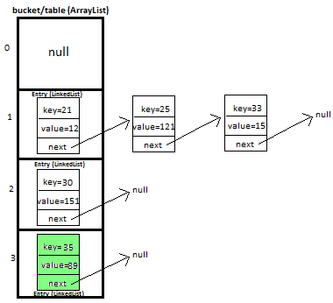
In this tutorial we will learn how to create and implement own/custom HashMap in java with full working source code.

This is very important and trending topic in java. In this post i will be explaining HashMap custom implementation in lots of detail with diagrams which will help you in visualizing the HashMap implementation.

I will be explaining how we will put and get key-value pair in HashMap by overriding-
>equals method - helps in checking equality of entry objects.
>hashCode method - helps in finding bucket’s index on which data will be stored.

We will maintain bucket (ArrayList) which will store Entry (LinkedList).

2) Entry<K,V>
We store key-value pair by using Entry<K,V>
Entry contains
- K key,
- V value and
- Entry<K,V> next (i.e. next entry on that location of bucket).
static class Entry<K, V> {
K key;
V value;
Entry<K,V> next;

public Entry(K key, V value, Entry<K,V> next){
this.key = key;
this.value = value;
this.next = next;
}
}

3) Putting 5 key-value pairs in own/custom HashMap (step-by-step) in java>
I will explain you the whole concept of HashMap by putting 5 key-value pairs in HashMap.

Initially, we have bucket of capacity=4. (all indexes of bucket i.e. 0,1,2,3 are pointing to null)
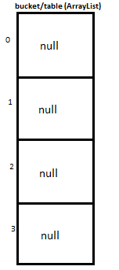

Let’s put first key-value pair in HashMap-
Key=21, value=12
newEntry Object will be formed like this >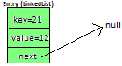

We will calculate hash by using our hash(K key) method - in this case it returns
key/capacity= 21%4= 1.
So, 1 will be the index of bucket on which newEntry object will be stored.
We will go to 1st index as it is pointing to null we will put our newEntry object there.

At completion of this step, our HashMap will look like this-

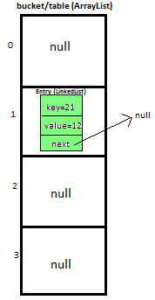

Let’s put second key-value pair in HashMap-
Key=25, value=121
newEntry Object will be formed like this >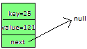

We will calculate hash by using our hash(K key) method - in this case it returns
key/capacity= 25%4= 1.
So, 1 will be the index of bucket on which newEntry object will be stored.
We will go to 1st index, it contains entry with key=21, we will compare two keys(i.e. compare 21 with 25 by using equals method), as two keys are different we check whether entry with key=21’s next is null or not, if next is null we will put our newEntry object on next.

At completion of this step our HashMap will look like this-
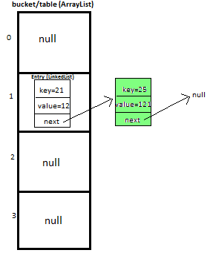

Let’s put third key-value pair in HashMap-
Key=30, value=151
newEntry Object will be formed like this >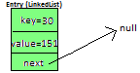

We will calculate hash by using our hash(K key) method - in this case it returns
key/capacity= 30%4= 2.
So, 2 will be the index of bucket on which newEntry object will be stored.
We will go to 2nd index as it is pointing to null we will put our newEntry object there.

At completion of this step, our HashMap will look like this-
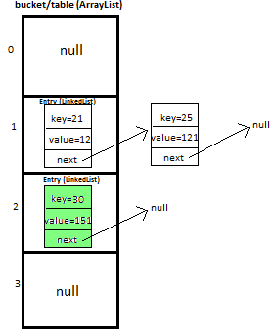

Let’s put fourth key-value pair in HashMap-
Key=33, value=15
Entry Object will be formed like this >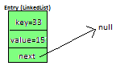

We will calculate hash by using our hash(K key) method - in this case it returns
key/capacity= 33%4= 1,
So, 1 will be the index of bucket on which newEntry object will be stored.

We will go to 1st index -
>it contains entry with key=21, we will compare two keys (i.e. compare 21 with 33 by using equals method, as two keys are different, proceed to next of entry with key=21 (proceed only if next is not null).
>now, next contains entry with key=25, we will compare two keys (i.e. compare 25 with 33 by using equals method, as two keys are different, now next of entry with key=25 is pointing to null so we won’t proceed further, we will put our newEntry object on next.

At completion of this step our HashMap will look like this-

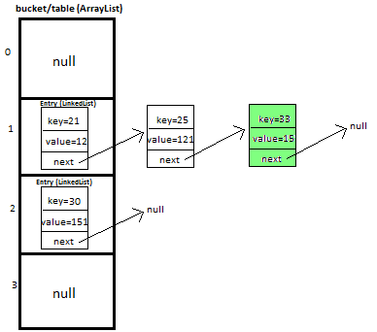

Let’s put fifth key-value pair in HashMap-
Key=35, value=89

Repeat above mentioned steps.

At completion of this step our HashMap will look like this-


4) Methods used in custom HashMap in java >
public void put(K newKey, V data) | -Method allows you put key-value pair in HashMap  -If the map already contains a mapping for the key, the old value is replaced.  -provide complete functionality how to override equals method.  -provide complete functionality how to override hashCode method.
public V get(K key) | Method returns value corresponding to key.
public boolean remove(K deleteKey) | Method removes key-value pair from HashMapCustom.
public void display() | -Method displays all key-value pairs present in HashMapCustom.,  -insertion order is not guaranteed, for maintaining insertion order refer LinkedHashMapCustom.
private int hash(K key) | -Method implements hashing functionality, which helps in finding the appropriate bucket location to store our data.  -This is very important method, as performance of HashMapCustom is very much dependent on this method's implementation.

5) What will happen if map already contains mapping for key?
If the map already contains a mapping for the key, the old value is replaced.

7) Complexity calculation of put and get methods in HashMap in java >

7.1) put method - worst Case complexity >

O(n).

But how complexity is O(n)?
Initially, let's say map is like this -

And we have to insert newEntry Object with Key=25, value=121 

We will calculate hash by using our hash(K key) method - in this case it returns
key/capacity= 25%4= 1.
So, 1 will be the index of bucket on which newEntry object will be stored.
We will go to 1st index, it contains entry with key=21, we will compare two keys(i.e. compare 21 with 25 by using equals method), as two keys are different we check whether entry with key=21’s next is null or not, if next is null we will put our newEntry object on next.

At completion of this step our HashMap will look like this-


Now let’s do complexity calculation -
Earlier there was 1 element in HashMap and for putting newEntry Object we iterated on it. Hence complexity was O(n).
Note: We may calculate complexity by adding more elements in HashMap as well, but to keep explanation simple i kept less elements in HashMap.

7.2) put method - best Case complexity >

O(1).

But how complexity is O(1)?
Let's say map is like this -

And we have to insert newEntry Object with Key=30, value=151 

We will calculate hash by using our hash(K key) method - in this case it returns
key/capacity= 30%4= 2.
So, 2 will be the index of bucket on which newEntry object will be stored.
We will go to 2nd index as it is pointing to null we will put our newEntry object there.

At completion of this step our HashMap will look like this-


Now let’s do complexity calculation -
Earlier there 2 elements in HashMap but we were able to put newEntry Object in first go. Hence complexity was O(1).

7.3) get method - worst Case complexity >

O(n).

But how complexity is O(n)?
Initially, let's say map is like this -

And we have to get Entry Object with Key=25, value=121 

We will calculate hash by using our hash(K key) method - in this case it returns
key/capacity= 25%4= 1.
So, 1 will be the index of bucket on which Entry object is stored.
We will go to 1st index, it contains entry with key=21, we will compare two keys(i.e. compare 21 with 25 by using equals method), as two keys are different we check whether entry with key=21’s next is null or not, next is not null so we will repeat same process and ultimately will be able to get Entry object.

Now let’s do complexity calculation -
There were 2 elements in HashMap and for getting Entry Object we iterated on both of them. Hence complexity was O(n).
Note: We may calculate complexity by using HashMap of larger size, but to keep explanation simple i kept less elements in HashMap.

7.4) get method - best Case complexity >

O(1).

But how complexity is O(1)?
Initially, let's say map is like this -

And we have to get Entry Object with Key=30, value=151 
We will calculate hash by using our hash(K key) method - in this case it returns
key/capacity= 30%4= 2.
So, 2 will be the index of bucket on which Entry object is stored.
We will go to 2nd index and get Entry object.

Now let’s do complexity calculation -
There were 3 elements in HashMap but we were able to get Entry Object in first go.
Hence complexity was O(1).

8) Summary of complexity of methods in HashMap in java >
Operation/ method | Worst case | Best case
put(K key, V value) | O(n) | O(1)
get(Object key) | O(n) | O(1)

Collection interview Question 24. How to implement own LinkedHashMap in java? Or LinkedHashMap works in java?
Answer.
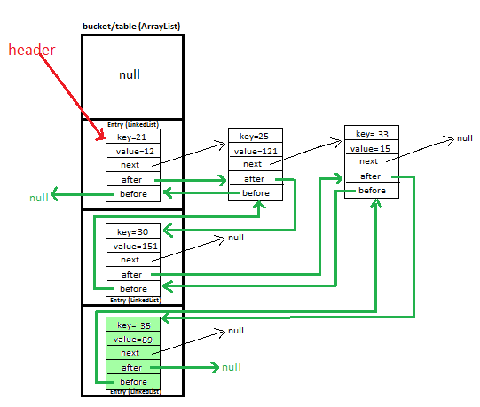

I will be explaining how we will put and get key-value pair in HashMap by overriding-
>equals method - helps in checking equality of entry objects.
>hashCode method - helps in finding bucket’s index on which data will be stored.
We will maintain bucket (ArrayList) which will store Entry (LinkedList).

Most salient feature of LinkedHashMap is that it maintains insertion order of key-value pairs. We will maintain doubly Linked List for doing so.
While our HashMap didn’t maintained insertion order.

2) Entry<K,V>
We store key-value pair by using Entry<K,V>
By using, Entry<K,V> before, after - we keep track of newly added entry in LinkedHashMap, which helps us in maintaining insertion order.

Entry contains
- K key,
- V value,
- Entry<K,V> next (i.e. next entry on that location of bucket),
- Entry<K,V> before and
- Entry<K,V> after

static class Entry<K, V> {
K key;
V value;
Entry<K,V> next;
Entry<K,V> before, after ;

public Entry(K key, V value, Entry<K,V> next){
this.key = key;
this.value = value;
this.next = next;
}
}

3) Putting 5 key-value pairs in own/custom LinkedHashMap (step-by-step)>
I will explain you the whole concept of LinkedHashMap by putting 5 key-value pairs in HashMap.

Initially, we have bucket of capacity=4. (all indexes of bucket i.e. 0,1,2,3 are pointing to null)

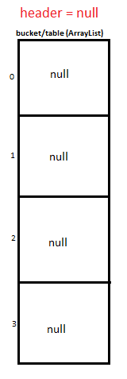

Let’s put first key-value pair in LinkedHashMap-
Key=21, value=12
newEntry Object will be formed like this >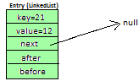

We will calculate hash by using our hash(K key) method - in this case it returns
key/capacity= 21%4= 1.
So, 1 will be the index of bucket on which newEntry object will be stored.
We will go to 1st index as it is pointing to null we will put our newEntry object there.

Additionally, for maintaining insertion order-
Update header, it will start pointing to newEntry object

At completion of this step, our HashMap will look like this-

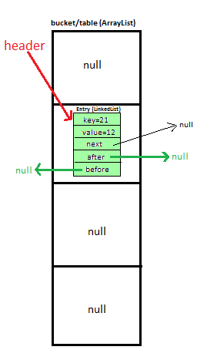

Let’s put second key-value pair in LinkedHashMap-
Key=25, value=121
newEntry Object will be formed like this >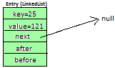

We will calculate hash by using our hash(K key) method - in this case it returns
key/capacity= 25%4= 1.
So, 1 will be the index of bucket on which newEntry object will be stored.
We will go to 1st index, it contains entry with key=21, we will compare two keys(i.e. compare 21 with 25 by using equals method), as two keys are different we check whether entry with key=21’s next is null or not, if next is null we will put our newEntry object on next.

Additionally, for maintaining insertion order-
Update header.after, it will start pointing to newEntry object (i.e make Entry with key=21’s after point to newEntry object], and also make newEntry object’s before point to header (Entry with key=21’)

At completion of this step our HashMap will look like this-
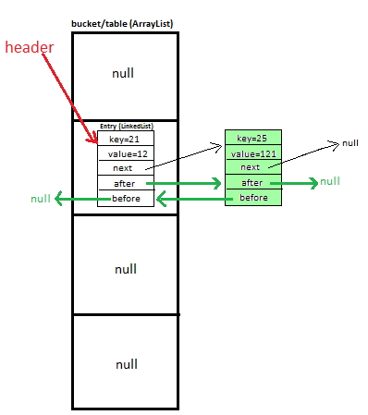
Let’s put third key-value pair in HashMap-
Key=30, value=151
newEntry Object will be formed like this >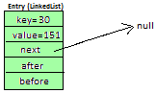

We will calculate hash by using our hash(K key) method - in this case it returns
key/capacity= 30%4= 2.
So, 2 will be the index of bucket on which newEntry object will be stored.
We will go to 2nd index as it is pointing to null we will put our newEntry object there.

Additionally, for maintaining insertion order-
Update doubly linked list ’s after and before.

At completion of this step, our HashMap will look like this-
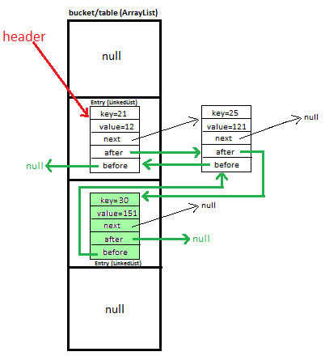
Let’s put fourth key-value pair in LinkedHashMap-
Key=33, value=15
Entry Object will be formed like this >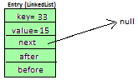

We will calculate hash by using our hash(K key) method - in this case it returns
key/capacity= 33%4= 1,
So, 1 will be the index of bucket on which newEntry object will be stored.

We will go to 1st index -
>it contains entry with key=21, we will compare two keys (i.e. compare 21 with 33 by using equals method, as two keys are different, proceed to next of entry with key=21 (proceed only if next is not null).
>now, next contains entry with key=25, we will compare two keys (i.e. compare 25 with 33 by using equals method, as two keys are different, now next of entry with key=25 is pointing to null so we won’t proceed further, we will put our newEntry object on next.

Additionally, for maintaining insertion order-
Update doubly linked list’s after and before (for maintaining insertion order)

At completion of this step our HashMap will look like this-

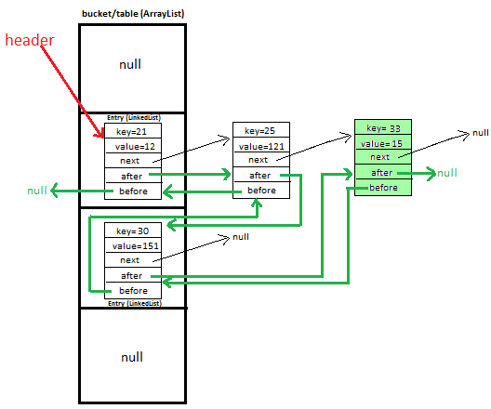

Let’s put fifth key-value pair in LinkedHashMap-
Key=35, value=89
Repeat above mentioned steps.

At completion of this step our HashMap will look like this-
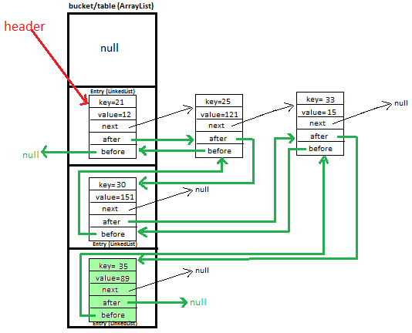
4) Methods used in custom LinkedHashMap >
public void put(K newKey, V data) | -Method allows you put key-value pair in HashMap  -If the map already contains a mapping for the key, the old value is replaced.  -provide complete functionality how to override equals method.  -provide complete functionality how to override hashCode method.
public V get(K key) | Method returns value corresponding to key.
public boolean remove(K deleteKey) | Method removes key-value pair from LinkedHashMapCustom.
public void display() | -Method displays all key-value pairs present in LinkedHashMapCustom.,  -insertion order is guaranteed.
private int hash(K key) | -Method implements hashing functionality, which helps in finding the appropriate bucket location to store our data.  -This is very important method, as performance of LinkedHashMapCustom is very much dependent on this method's implementation.
private void maintainOrderAfterInsert(Entry<K, V> newEntry) | Methods helps in maintaining insertion order after insertion of key-value pair.
Private void maintainOrderAfterDeletion(Entry<K, V> deleteEntry) | Methods helps in maintaining insertion order after deletion of key-value pair.

6) Complexity calculation of put and get methods in LinkedHashMap >

Complexity offered by put and get methods of LinkedHashMap is same as that of HashMap. Additionally, for maintaining insertion order during put method - doubly linked list’s header, after and before are also updated (whichever is needed to be updated).

6.1) put method - worst Case complexity >

O(n) + for maintaining insertion order during put method - doubly linked list’s header, after and before are also updated (whichever is needed to be updated).

6.2) put method - best Case complexity >

O(1). for maintaining insertion order during put method - doubly linked list’s header, after and before are also updated (whichever is needed to be updated).

6.3) get method - worst Case complexity >

O(n)

6.4) get method - best Case complexity >

O(1)

Collection interview Question 25. How to implement own ArrayList in java? Or How ArrayList works in java ?
Answer.

Custom ArrayList in java >

In this post i will be explaining ArrayList Custom implementation.

Initially, when we declare ArrayList<Integer> with INITIAL_CAPACITY = 10, it will be like this-


Let’s add(71) in ArrayList, after addition our ArrayList will look like this-

2) Methods used in custom ArrayList in java >
public void add(E value) | Add objects in ArrayListCustom
public E get(int index) | Method returns element on specific index.
public Object remove(int index) | Method returns removedElement on specific index, else it throws IndexOutOfBoundException if index is negative or greater than size of size.
public void display() | -Method displays all objects in ArrayListCustom.  -Insertion order is guaranteed.
private void ensureCapacity() | Method increases capacity of list by making it double.

4) Complexity of methods in ArrayList in java >
Operation/ method | Worst case | Best case
add | O(n), when array is full it needs restructuring,  operation runs in amortized constant time. | O(1), when array does not need any restructuring.
remove | O(n), when removal is done from between restructuring is needed. | O(1), when removal is done at last position, no restructuring is needed.
get | O(1), it is index based structure. So, complexity of get operation is always done in O(1). | O(1) it is index based structure. So, complexity of get operation is always done in O(1).
display | O(n), because iteration is done over each and every element. | O(n), because iteration is done over each and every element.

Collection interview Question 26. How to implement own HashSet in java? Or How HashSet works in java ?
Answer.

Methods used in custom HashMap >
public void add(E value) | Add objects in setCustom
public boolean contains(E obj) | Method returns true if setCustom contains the object.
public boolean remove(E obj) | Method removes object from setCustom.
public void display() | -Method displays all objects in setCustom.  -Insertion order is not guaranteed, for maintaining insertion order refer LinkedHashSet.

2) Let’s find out answer of few very important questions before proceeding >

Q1. How HashSet implements hashing?
A. Method internally uses HashMap’s hash method for hashing.

Q2. How add method works internally?
public void add(E value)
{
hashMapCustom.put(value, null);
}

Method internally uses HashMap’s put method for storing object.

Q3. How contains method works internally?
. public boolean contains(E obj)
{
return hashMapCustom.contains(obj) !=null ? true :false;
}

Method internally uses HashMap’s contains method for storing object.

Q4. How remove method works internally?
public boolean remove(E obj)
{
return hashMapCustom.remove(obj);
}

Method internally uses HashMap’s put remove for storing object.

Collection interview Question 27. How to implement own LinkedHashSet in java? Or How LinkedHashSet works in java ?
Answer.

Methods used in custom LinkedHashSet in java >
public void add(E value) | Add objects in setCustom
public boolean contains(E obj) | Method returns true if setCustom contains the object.
public boolean remove(E obj) | Method removes object from setCustom.
public void display() | -Method displays all objects in setCustom.  -Insertion order is guaranteed.

Most salient feature of LinkedHashSet is that it maintains insertion order of objects. We will be internally using LinkedHashMap.

2) Let’s find out answer of few very important questions before proceeding.

Q1. How LinkedHashSet implements hashing?
A. Method internally uses LinkedHashMap’s hash method for hashing.

Q2. How add method works internally?
public void add(E value){
linkedHashMapCustom.put(value, null);
}
Method internally uses LinkedHashMapCustom’s put method for storing object.

Q3. How contains method works internally?
A. public boolean contains(E obj){
return linkedHashMapCustom.contains(obj) !=null ? true :false;
}
Method internally uses LinkedHashMapCustom’s contains method for storing object.

Q4. How remove method works internally?
A. public boolean remove(E obj){
return linkedHashMapCustom.remove(obj);
}
Method internally uses LinkedHashMapCustom’s put remove for storing object.

Question 28. What do you mean by fail-fast and fast-safe? What is ConcurrentModificationException?
Answer.
Iterator returned by few Collection framework Classes are fail-fast, means any structural modification made to these classes during iteration will throw ConcurrentModificationException.
Some important classes whose returned iterator is fail-fast >
- ArrayList
- LinkedList
- vector
- HashSet

Iterator returned by few Collection framework Classes are fail-safe, means any structural modification made to these classes during iteration won’t throw any Exception.
Some important classes whose returned iterator is fail-safe >
- CopyOnWriteArrayList
- CopyOnWriteArraySet
- ConcurrentSkipListSet

Collection interview Question 29. What are different ways of iterating over elements in List?
Answer.
Creating ArrayList and add element.
List<String> arrayList=new ArrayList<String>();
arrayList.add("javaMadeSoEasy");

Iterate over elements in ArrayList using iterator()
iterator() method returns iterator to iterate over elements in ArrayList.

Iterator<String> iterator=arrayList.iterator();
while(iterator.hasNext()){
System.out.println(iterator.next());
}
iterator returned by ArrayList is fail-fast.

Iterate over elements in ArrayList using listIterator()
ListIterator<String> listIterator=arrayList.listIterator();
ListIterator returned by ArrayList is also fail fast.

Iterate over elements in list using enumeration
Enumeration<String> listEnum=Collections.enumeration(arrayList);
while(listEnum.hasMoreElements()){
System.out.println(listEnum.nextElement());
}
enumeration is also fail-fast.

Iterate over elements in list using enhanced for loop
for (String string : arrayList) {
System.out.println(string);
}
enhanced for loop is also fail-fast.

Collection interview Question 30. What are different ways of iterating over elements in Set?
Answer. Creating HashSet and add element.
Set<String> hashSet=new HashSet<String>();
hashSet.add("javaMadeSoEasy");

Iterate over elements in HashSet using iterator()
iterator() method returns iterator to iterate over elements in HashSet.
Iterator<String> iterator=hashSet.iterator();
while(iterator.hasNext()){
System.out.println(iterator.next());
}
iterator returned by HashSet is fail-fast.

Iterate over elements in Set using enumeration
Enumeration<String> listEnum=Collections.enumeration(set);
while(listEnum.hasMoreElements()){
System.out.println(listEnum.nextElement());
}
enumeration is also fail-fast.

Iterate over elements in Set using enhanced for loop
for (String string : set) {
System.out.println(string);
}
enhanced for loop is also fail-fast.

Collection interview Question 31. What are different ways of iterating over keys, values and entry in Map?

Answer. Create and put key-value pairs in HashMap >
Map<Integer,String> hashMap=new HashMap<Integer,String>();
hashMap.put(11, "javaMadeSoEasy");
hashMap.put(21, "bmw");
hashMap.put(31, "ferrari");

Iterate over keys -
hashMap.keySet().iterator() method returns iterator to iterate over keys in HashMap.

Iterator<Integer> keyIterator=hashMap.keySet().iterator();
while(keyIterator.hasNext()){
System.out.println(keyIterator.next());
}

/*OUTPUT
21
11
31
*/
Iterate over values -
hashMap.values().iterator() method returns iterator to iterate over values in HashMap.

Iterator<String> valueIterator=hashMap.values().iterator();
while(valueIterator.hasNext()){
System.out.println(valueIterator.next());
}

/*OUTPUT
javaMadeSoEasy
audi
ferrari
*/
iterator returned is fail-fast..

Iterate over Entry-
hashMap.entrySet().iterator() method returns iterator to iterate over Entry in HashMap.

Iterator<Entry<Integer, String>> entryIterator=hashMap.entrySet().iterator();
while(entryIterator.hasNext()){
System.out.println(entryIterator.next());
}

/*OUTPUT
21=javaMadeSoEasy
11=audi
31=ferrari
*/
iterator returned is fail-fast..

Collection interview Question 32. What is difference between Comparable and Comparator? How can you sort List?
Answer.

 | Property | Comparable | Comparator
1 | Comparing instances of class | Comparable is used to compare instances of same class | Comparator can be used to compare instances of same or different classes.
2 | sorting order | Comparable can be implemented by class which need to define a natural ordering for its objects.  Example - String, Integer, Long , Date and all other wrapper classes implements Comparable. | Comparator is implemented when one wants a different sorting order and define custom way of comparing two instances.
3 | Changes to class | For using Comparable, original Class must implement it.  Example-  class Employee implements Comparable<Employee>  For using Comparable, Employee Class must implement it, no other class can implement it.  As used in Program 1 | Class itself can implement Comparator  or  any other class can implement Comparator. Hence avoiding modification to original class.  Example-  class ComparatorName implements Comparator<Employee>  class ComparatorId implements Comparator<Employee>  In above example modifications were made to ComparatorName and ComparatorId. Hence avoiding modification to Employee class.  As used in Program 4
4 | Sorting on basis on one or many criteria | Provides sorting only on one criteria, because Comparable can be implemented by original class only. | We can use Comparator to sort class on many criterias because class itself or any other class can implement Comparator.
5 | Method | compareTo method  @Override  public int compareTo(Employee obj) {  //sort Employee on basis of name(ascending order)  return this.name.compareTo(obj.name);  }  Method compares this with obj object and returns a integer.  - positive – this is greater than obj  - zero – this is equal to obj  - negative – this is less than obj  As used in Program 1 | compare method  @Override  public int compare(Employee obj1, Employee obj2) {  //sort Employee on basis of name(ascending order)  return obj1.name.compareTo(obj2.name);  }  Method compares obj1 with obj2 object and returns a integer.  - positive – obj1 is greater than obj2  - zero – obj1 is equal to obj2  - negative – obj1 is less than obj2  As used in Program 3
6 | Package | java.lang  java.lang package is automatically imported by every program in java.  Hence, we need to write explicit statement for importing java.lang.Comparable. | java.util  We need to write explicit import statement -  import java.util.Comparator
7 | Using Collections.sort | Let's say we wanna sort list of Employee,  Collections.sort(list) uses Comparable interface for sorting class.  As used in Program 1 | Let's say we wanna sort list of Employee,  Collections.sort(list,new ComparatorName());  uses Comparator interface for sorting class.  As used in Program 5

Collection interview Question 33. How sort method of Collections class works internally?
Answer. Collections.sort internally calls Arrays.sort,
Arrays.Sort() internally uses Merge Sort.
If number of elements is less than 7 then Insertion Sort is used rather than Merge Sort. (because in case elements are less than 7 it offers better time complexity)

Collection interview Question 34. How can you sort given HashMap on basis of keys?
Answer.

Logic to Sort Map by key in Ascending order in java
Implement Comparator interface and override its compare method in java.
Obtain map.entrySet() in set, convert it into list (we have converted set to list because Collections’s sort method can accept only list type as parameter).
Call Collections.sort and pass list [i.e. listOfentrySet] as parameter.
Collections.sort internally calls Arrays.sort,
Arrays.Sort() internally calls Merge Sort.
Merge sort calls overridden compare method of Comparator interface for comparison of keys.
Ultimately listOfentrySet will contain entry (key-value) pairs sorted on basis of keys in java.

Must know fact :
If number of elements is less than 7 then Insertion Sort is used rather than Merge Sort. (because in case elements are less than 7 it offers better time complexity)

Example/Program 1 to Sort Map by key in Ascending order by implementing Comparator interface and overriding its compare method in java
import java.util.ArrayList;
import java.util.Set;
class SortByKeyAscending implements Comparator<Map.Entry<Integer, Integer>>{
@Override
public int compare( Map.Entry<Integer,Integer> entry1, Map.Entry<Integer,Integer> entry2){
return (entry1.getKey()).compareTo( entry2.getKey() );
}
}
/**
*/
public class SortMapByKeyAscendingExample {
public static void main(String...a){
Map<Integer, Integer> map = new LinkedHashMap<Integer, Integer>();
map.put(4, 1);
map.put(2, 1);
map.put(3, 1);
map.put(5, 1);

Set<Entry<Integer, Integer>> entrySet = map.entrySet();
List<Entry<Integer, Integer>> listOfentrySet = new ArrayList<Entry<Integer, Integer>>(entrySet);

System.out.print("Before sorting by key : ");
for(Map.Entry<Integer, Integer> entry:listOfentrySet){
System.out.print(entry.getKey()+"="+entry.getValue()+" ");
}

Collections.sort(listOfentrySet, new SortByKeyAscending());

System.out.print("\nAfter sorting by key(ascending): ");
for(Map.Entry<Integer, Integer> entry:listOfentrySet)
System.out.print(entry.getKey()+"="+entry.getValue()+" ");

}
}
/*OUTPUT
Before sorting by key : 4=1 2=1 3=1 5=1
After sorting by key(ascending): 2=1 3=1 4=1 5=1
*/
Note : In the above program, only listOfentrySet obtained from map contain entry (key-value) pairs sorted on basis of keys, map is not sorted on basis of keys. We will learn sorting of map in Program 3 and Program 4 below.

Example/Program 2 to Sort Map by key in Descending order by implementing Comparator interface and overriding its compare method in java
In the above program replace SortByKeyAscending class with below SortByKeyDescending class.
class SortByKeyDescending implements Comparator<Map.Entry<Integer, Integer>>{
@Override
public int compare( Map.Entry<Integer,Integer> entry1, Map.Entry<Integer,Integer> entry2){
return (entry2.getKey()).compareTo( entry1.getKey() );
}
}

OUTPUT will be >
/*OUTPUT
Before sorting by key : 4=1 2=1 3=1 5=1
After sorting by key(descending) : 5=1 4=1 3=1 2=1
*/

Example/Program 3 to Sort Map by key in Ascending order by using TreeMap, where key is Integer type.
TreeMap is sorted by natural order of keys in java.
import java.util.Map;
import java.util.TreeMap;
public class SortMapByKeyAscendingExample {
public static void main(String...a){
Map<Integer, Integer> treeMap = new TreeMap<Integer, Integer>();
treeMap.put(4, 1);
treeMap.put(2, 1);
treeMap.put(3, 1);
treeMap.put(5, 1);
System.out.println("treeMap : "+treeMap);

}
}
/*OUTPUT
treeMap : {2=1, 3=1, 4=1, 5=1}
*/

TreeMap’s putAll method or constructor >

If elements are stored in HashMap or any other collection class that implements Map we can use TreeMap’s putAll method or constructor to sort map on basis of key in java.

Let’s see Example in java >

HashMap -
Map<Integer, Integer> hashMap = new HashMap<Integer, Integer>();
hashMap.put(4, 1);
hashMap.put(2, 1);
hashMap.put(3, 1);

TreeMap’s putAll method -
Map<Integer, Integer> treeMap = new TreeMap<Integer, Integer>();
treeMap.putAll(hashMap);

TreeMap’s constructor -
Map<Integer, Integer> treeMap = new TreeMap<Integer, Integer>(hashMap);

Important Note :
- If any class that implements Map contains null key - If any class that implements Map contains null key and is converted into TreeMap than NullPointerException (RunTimeException) will be thrown in java.

Example/Program 4 to Sort Map by key in Ascending order by using TreeMap and implementing Comparable interface, where key is customObject/Employee type in java.

TreeMap is sorted by natural order of keys in java.
In program 3 we used Integer as key, Integer class implements Comparable interface and overrides its compareTo() method.
But, for using Employee as key we it must implement Comparable interface and override its compareTo() method in java.

Note : If we Employee don’t implement Comparable interface and override its compareTo() method than ClassCastException (RunTimeException) will be thrown. Because, internally TreeMap calls compare method for comparing keys , while comparing keys casting to java.lang.Comparable will fail at runtime.
import java.util.Map;
import java.util.TreeMap;
class Employee implements Comparable<Employee>{
String name;
String id;
public Employee(String name, String id) {
this.name = name;
this.id = id;
}

@Override
public int compareTo(Employee otherEmployee) {
//sort Employee on basis of name(ascending order)
return this.name.compareTo(otherEmployee.name);
}
@Override
public String toString() {
return "Employee{" + "name=" + name + ", id=" + id + '}';
}
}

public class SortMapByKeyAscendingExample {
public static void main(String...a){
Employee emp1=new Employee("sam","4");
Employee emp2=new Employee("amy","2");
Employee emp3=new Employee("brad","1");
Map<Employee, Integer> treeMap = new TreeMap<Employee, Integer>();
treeMap.put(emp1, 1);
treeMap.put(emp2, 1);
treeMap.put(emp3, 1);
System.out.println("treeMap : "+treeMap);

}
}
/*OUTPUT
treeMap : {Employee{name=amy, id=2}=1, Employee{name=brad, id=1}=1, Employee{name=sam, id=4}=1}
*/

Example/Program 5 to Sort Map by key in descending order by using TreeMap and implementing Comparator interface, where key is Integer type.

TreeMap is sorted by natural order of keys, but we will implement Comparator interface to change the behaviour to sort TreeMap in descending order of keys.
Comparator interface has been used in form of anonymous inner class in java.
import java.util.Comparator;
import java.util.Map;
import java.util.TreeMap;

public class SortMapByKeyAscendingExample {
public static void main(String...a){
Map<Integer,Integer> treeMap = new TreeMap<Integer,Integer>(new Comparator<Integer>(){
@Override
public int compare(Integer o1, Integer o2) {
//using Comparator to sort map in descending order of keys.
return o2.compareTo(o1);
}
});
treeMap.put(4, 1);
treeMap.put(2, 1);
treeMap.put(3, 1);
treeMap.put(5, 1);

System.out.println("treeMap : "+treeMap);

}
}
/*OUTPUT
treeMap : {5=1, 4=1, 3=1, 2=1}

*/

Collection interview Question 35. How can you sort given HashMap on basis of values?
Answer.
Logic to Sort Map by value in Ascending order in java
Implement Comparator interface and override its compare method.
Obtain map.entrySet() in set, convert it into list (we have converted set to list because Collections’s sort method can accept only list type as parameter).
Call Collections.sort and pass list [i.e. listOfentrySet] as parameter.
Collections.sort internally calls Arrays.sort,
Arrays.Sort() internally uses Merge Sort.
Merge sort calls overridden compare method of Comparator interface for comparison of values.
Ultimately listOfentrySet will contain entry (key-value) pairs sorted on basis of values.

Must know fact :
If number of elements is less than 7 then Insertion Sort is used rather than Merge Sort. (because in case elements are less than 7 it offers better time complexity)

Example/Program 1 to Sort Map by value in Ascending order by implementing Comparator interface and overriding its compare method in java
import java.util.ArrayList;
class SortByValue implements Comparator<Map.Entry<Integer, Integer>>{
@Override
public int compare( Map.Entry<Integer,Integer> entry1, Map.Entry<Integer,Integer> entry2){
return (entry1.getValue()).compareTo( entry2.getValue() );
}
}

/**
*/
public class SortMapByValueAscendingExample {
public static void main(String...a){
Map<Integer, Integer> map = new HashMap<Integer, Integer>();
map.put(1, 2);
map.put(2, 1);
map.put(3, 9);
map.put(4, 8);

Set<Entry<Integer, Integer>> entrySet = map.entrySet();
List<Entry<Integer, Integer>> listOfentrySet = new ArrayList<Entry<Integer, Integer>>(entrySet);

System.out.print("Before sorting by value: ");
for(Map.Entry<Integer, Integer> entry:listOfentrySet){
System.out.print(entry.getKey()+"="+entry.getValue()+" ");
}

Collections.sort(listOfentrySet, new SortByValue());

System.out.print("\nAfter sorting by value(ascending): ");
for(Map.Entry<Integer, Integer> entry:listOfentrySet)
System.out.print(entry.getKey()+"="+entry.getValue()+" ");

}
}
/*OUTPUT
Before sorting by value: 1=2 2=1 3=9 4=8
After sorting by value(ascending): 2=1 1=2 4=8 3=9
*/
Note : In the above program, only listOfentrySet obtained from map contain entry (key-value) pairs sorted on basis of values, map is not sorted on basis of values.

Example/Program 2 to Sort Map by value in Descending order by implementing Comparator interface and overriding its compare method in java
In the above program replace SortByValue class with below SortByValue class in java.
class SortByValue implements Comparator<Map.Entry<Integer, Integer>>{
@Override
public int compare( Map.Entry<Integer,Integer> entry1, Map.Entry<Integer,Integer> entry2){
return (entry2.getValue()).compareTo( entry1.getValue() );
}
}

OUTPUT will be >
/*OUTPUT
Before sorting by value: 1=2 2=1 3=9 4=8
After sorting by value(descending): 3=9 4=8 1=2 2=1
*/

Collection interview Question 36. In what all possible ways you can sort a given Set?
Answer.

Example/Program 1 to Sort Set by using TreeSet(by default elements are sorted in ascending order), where elements are Integer type in java.
TreeSet is sorted by natural order of elements (i.e. in ascending order) in java.
import java.util.TreeSet;
import java.util.Set;
/**
*/
public class SortSetExample {
public static void main(String...a){
Set<Integer> treeSet = new TreeSet<Integer>();
treeSet.add(3);
treeSet.add(1);
treeSet.add(2);
System.out.println("treeSet : "+treeSet);

}
}
/*OUTPUT
treeSet : [1, 2, 3]
*/

TreeMap’s addAll method or constructor for sorting in java>
If elements are stored in HashSet/ArrayList or any other class that implements Collection we can use TreeSet’s addAll method or constructor for sorting.

Let’s see Example in java >

Collection-
Collection<Integer> collection = new HashSet<Integer>();
collection.add(3);
collection.add(1);
collection.add(2);

TreeSet’s addAll method -
Set<Integer> treeSet = new TreeSet<Integer>();
treeSet.addAll(collection);

TreeSet’s constructor -
Set<Integer> treeSet = new TreeSet<Integer>(collection);

Important Note :
- If any class that implements Collection contains null - If any class that implements Collection contains null and is converted into TreeSet than NullPointerException (RunTimeException) will be thrown in java.
- If any class that implements List is converted into TreeSet - Than that class’s duplicate elements will be lost, because any of the Set implementation ( TreeSet or may be any other class) does not allow to store duplicate elements in java.

Example/Program 2 to Sort Set by using TreeSet(we will define Comparator to sort elements in descending order), where elements are Integer type in java.
TreeSet is sorted by natural order of elements (i.e. in ascending order), but we will implement Comparator interface and change the behaviour to sort elements in descending order in java.
import java.util.Comparator;
import java.util.Set;
import java.util.TreeSet;
/**
*/
public class SortSetExample {
public static void main(String...a){
Set<Integer> treeSet = new TreeSet<Integer>(new Comparator<Integer>() {
@Override
public int compare(Integer o1, Integer o2) {
//using Comparator to sort elements in descending order.
return o2.compareTo(o1);
}
});
treeSet.add(3);
treeSet.add(1);
treeSet.add(2);
System.out.println("treeSet : "+treeSet);

}
}
/*OUTPUT
treeSet : [3, 2, 1]
*/

Example/Program 3 to Sort Set in Ascending order by using TreeSet and implementing Comparable interface, where elements are customObject/Employee type in java.
TreeSet is sorted by natural order of elements in java.
In program 1 we used elements of Integer type, Integer class implements Comparable interface and overrides its compareTo() method.
But, for using Employee as elements we it must implement Comparable interface and override its compareTo() method.

Note : If we Employee don’t implement Comparable interface and override its compareTo() method than ClassCastException (RunTimeException) will be thrown. Because, internally TreeSet uses TreeMap for storing elements and TreeMap calls compare method for comparing elements, while comparing elements casting to java.lang.Comparable will fail at runtime.
import java.util.Set;
import java.util.TreeSet;
class Employee implements Comparable<Employee>{
String name;
String id;
public Employee(String name, String id) {
this.name = name;
this.id = id;
}

@Override
public int compareTo(Employee otherEmployee) {
//sort Employee on basis of name(ascending order)
return this.name.compareTo(otherEmployee.name);
}
@Override
public String toString() {
return "Employee{" + "name=" + name + ", id=" + id + '}';
}
}
/**
*
*/
public class SortSetExample {
public static void main(String...a){
Employee emp1=new Employee("sam","4");
Employee emp2=new Employee("amy","2");
Employee emp3=new Employee("brad","1");
Set<Employee> treeSet = new TreeSet<Employee>();
treeSet.add(emp1);
treeSet.add(emp2);
treeSet.add(emp3);
System.out.println("treeSet : "+treeSet);

}
}
/*OUTPUT

treeSet : [Employee{name=amy, id=2}, Employee{name=brad, id=1}, Employee{name=sam, id=4}]

*/
Example/Program 4 to Sort Set in Ascending order by using TreeSet and implementing Comparator interface, where elements are customObject/Employee type in java.
In program 3, Employee implemented Comparable but in this program TreeSet will implement comparator interface.
Comparator interface has been used in form of anonymous inner class in java.

Note : If we Employee don’t implement Comparable interface neither Treeset implement Comparator interface than ClassCastException (RunTimeException) will be thrown. Because, internally TreeSet uses TreeMap for storing elements and TreeMap calls compare method for comparing elements, while comparing elements casting to java.lang.Comparable will fail at runtime.

import java.util.Comparator;
import java.util.Set;
import java.util.TreeSet;
class Employee{
String name;
String id;
public Employee(String name, String id) {
this.name = name;
this.id = id;
}
@Override
public String toString() {
return "Employee{" + "name=" + name + ", id=" + id + '}';
}
}
/**
*/
public class SortSetExample {
public static void main(String...a){
Employee emp1=new Employee("sam","4");
Employee emp2=new Employee("amy","2");
Employee emp3=new Employee("brad","1");
Set<Employee> treeSet = new TreeSet<Employee>(new Comparator<Employee>() {
@Override
public int compare(Employee o1, Employee o2) {
return o1.name.compareTo(o2.name);
}
});
treeSet.add(emp1);
treeSet.add(emp2);
treeSet.add(emp3);
System.out.println("treeSet : "+treeSet);

}
}
/*OUTPUT
treeSet : [Employee{name=amy, id=2}, Employee{name=brad, id=1}, Employee{name=sam, id=4}]
*/

So in this Collection framework tutorial we learned how to sort Set (using TreeSet and by implementing Comparator and Comparable interface) with lots of examples and programs in java.

Collection interview Question 37. How you can sort arrays? And how Comparator of superclass can be used by subclasses?
Answer.
Arrays.Sort() internally uses Merge Sort in java.
Merge sort calls overridden compare method of Comparator interface for comparison of values (if any).

Must know fact :
If number of elements is less than 7 then Insertion Sort is used rather than Merge Sort (because in case elements are less than 7 it offers better time complexity) in java.

Example/Program 1 to sort Integer array using Arrays.sort (by default Arrays.sort will sort array in ascending order) in java

import java.util.Arrays;

public class ArraysSortExample {
public static void main(String...a){
Integer intArray[]={2,3,1};

System.out.print("Array before sorting : ");
for(int i: intArray){
System.out.print(i+" ");
}
Arrays.sort(intArray);

System.out.print("\nArray after sorting : ");
for(int i: intArray){
System.out.print(i+" ");
}

}
}
/*OUTPUT
Array before sorting : 2 3 1
Array after sorting : 1 2 3
*/

Example/Program 2 to sort Integer array by using Arrays.sort (we will define Comparator to sort elements in descending order) in java
import java.util.Arrays;
import java.util.Comparator;
class SortDescending implements Comparator<Integer> {
@Override
public int compare(Integer o1, Integer o2) {
//using Comparator to sort array in descending order.
return o2.compareTo(o1);
}
}

public class ArraysSortExample {
public static void main(String...a){
Integer intArray[]={2,3,1};

System.out.print("Array before sorting : ");
for(int i: intArray){
System.out.print(i+" ");
}
Arrays.sort(intArray, new SortDescending());

System.out.print("\nArray after sorting in descending order : ");
for(int i: intArray){
System.out.print(i+" ");
}

}
}
/*OUTPUT
Array before sorting : 2 3 1
Array after sorting in descending order : 3 2 1
*/

Example/Program 3 to sort Employee array using Arrays.sort in ascending order on basis of name and id by implementing Comparator interface in java

import java.util.Arrays;
import java.util.Comparator;
class Employee{
String name;
String id;

public Employee() {}

public Employee(String name, String id) {
this.name = name;
this.id = id;
}

@Override
public String toString() {
return "Employee{" + "name=" + name + ", id=" + id + '}';
}

}
class ComparatorName implements Comparator<Employee>{
@Override
public int compare(Employee obj1, Employee obj2) {
//sort Employee on basis of name(ascending order)
return obj1.name.compareTo(obj2.name);
}

}
class ComparatorId implements Comparator<Employee>{
@Override
public int compare(Employee obj1, Employee obj2) {
//sort Employee on basis of id(ascending order)
return obj1.id.compareTo(obj2.id);
}

}

public class ArraysSortExample {
public static void main(String[] args) {
Employee emp1 = new Employee("sam", "4");
Employee emp2 = new Employee("amy", "2");
Employee emp3 = new Employee("brad", "1");
Employee employeeArray[] = { emp1, emp2, emp3 };
System.out.print(" employeeArray Before sorting : \n");
for (Employee emp : employeeArray) {
System.out.print(emp + " ");
}
Arrays.sort(employeeArray, new ComparatorName());
System.out.println("\n\n employeeArray after sorting on basis of "
+ "name(ascending order) : ");
for (Employee emp : employeeArray) {
System.out.print(emp + " ");
}
Arrays.sort(employeeArray, new ComparatorId());
System.out.println("\n\n employeeArray after sorting on basis of "
+ "id(ascending order) : ");
for (Employee emp : employeeArray) {
System.out.print(emp + " ");
}
}
}
/*OUTPUT
employeeArray Before sorting :
[Employee{name=sam, id=4}, Employee{name=amy, id=2}, Employee{name=brad, id=1}]
employeeArray after sorting on basis of name(ascending order) :
[Employee{name=amy, id=2}, Employee{name=brad, id=1}, Employee{name=sam, id=4}]
employeeArray after sorting on basis of id(ascending order) :
[Employee{name=brad, id=1}, Employee{name=amy, id=2}, Employee{name=sam, id=4}]
*/

Example/Program 4 to understand Comparator of superclass can be used by subclasses in java

Animal is superclass of Dog and Lion.
dogArray is array of dogs.
AnimalComparator is a Comparator of Animal class [ class AnimalComparator implements Comparator<Animal> ]

We will be using Arrays.sort(dogArray, new AnimalComparator()); in program.

Method definition of sort method in java.util.Arrays is -
public static <T> void sort(T[] a, Comparator<? super T> c)

So, what do you mean by second parameter Comparator<? super T> c


Let’s understand first parameter -
T[] a | dogArray has been passed as parameter which is array of Dog, and Dog extends Animal. So,  T is Dog, and  T[] is dogArray.

Now, let’s understand second parameter -
Comparator<? super T> c | In the program, following 2 lines have been used >  class Dog extends Animal (Animal is superclass of Dog),  class AnimalComparator implements Comparator<Animal>  (AnimalComparator is a Comparator of Animal class but it can be used by subclasses (i.e. Dog and Lion) as well.)

Full program -
import java.util.Arrays;
import java.util.Comparator;
/**
* Animal class
*/
class Animal{
Integer height;
}
/**
* Lion class
*/
class Lion extends Animal{
Lion(Integer height){
this.height=height;
}

@Override
public String toString() {
return "Lion [height=" + height + "]";
}
}
/**
* Dog class
*/
class Dog extends Animal{
Dog(Integer height){
this.height=height;
}
@Override
public String toString() {
return "Dog [height=" + height + "]";
}
}
/**
* Comparator to sort animal's height in ascending order.
*/
class AnimalComparator implements Comparator<Animal> {
@Override
public int compare(Animal o1, Animal o2) {
//using Comparator to sort animal's height in ascending order.
return o1.height.compareTo(o2.height);
}
}

public class ArraysSortExample {
public static void main(String...a){
System.out.println("-----Sorting Lion's height -- using AnimalComparator-----");
Lion lion1=new Lion(3);
Lion lion2=new Lion(1);
Lion lion3=new Lion(2);
Lion lionArray[]={lion1, lion2, lion3};

System.out.print(" lionArray before sorting : \n");
for (Animal animal : lionArray) {
System.out.print(animal + " ");
}
Arrays.sort(lionArray, new AnimalComparator());
System.out.println("\n\n lionArray after sorting on basis of "
+ "height(ascending order) : ");
for (Animal animal : lionArray) {
System.out.print(animal + " ");
}
System.out.println("\n\n\n------Sorting Dog's height -- using AnimalComparator----");

Dog dog1=new Dog(2);
Dog dog2=new Dog(1);
Dog dog3=new Dog(3);
Dog dogArray[]={dog1, dog2, dog3};

System.out.print(" dogArray before sorting : \n");
for (Animal animal : dogArray) {
System.out.print(animal + " ");
}
Arrays.sort(dogArray, new AnimalComparator());
System.out.println("\n\n dogArray after sorting on basis of "
+ "height(ascending order) : ");
for (Animal animal : dogArray) {
System.out.print(animal + " ");
}

}
}
/*OUTPUT
----------Sorting Lion's height -- using AnimalComparator----------
lionArray before sorting :
Lion [height=3] Lion [height=1] Lion [height=2]
lionArray after sorting on basis of height(ascending order) :
Lion [height=1] Lion [height=2] Lion [height=3]
--------Sorting Dog's height -- using AnimalComparator---------
dogArray before sorting :
Dog [height=2] Dog [height=1] Dog [height=3]
dogArray after sorting on basis of height(ascending order) :
Dog [height=1] Dog [height=2] Dog [height=3]
*/

Collection interview Question 38. What are differences between ArrayList vs CopyOnWriteArrayList?
Answer.

 | Property | java.util.ArrayList | java.util.concurrent. CopyOnWriteArrayList
1 | synchronization | ArrayList is not synchronized (because 2 threads on same ArrayList object can access it at same time).  I have created program to show see consequence of using ArrayList in multithreading environment.  In the program i will implement our own arrayList. | CopyOnWriteArrayList is synchronized (because 2 threads on same CopyOnWriteArrayList object cannot access it at same time).
2 | Iterator and listIterator | Iterator and listIterator returned by ArrayList are Fail-fast, means any structural modification made to ArrayList during iteration using Iterator or listIterator will throw ConcurrentModificationException in java.  As shown in Program 1 below. | Iterator and listIterator returned by CopyOnWriteArrayList are Fail-safe in java.  As shown in Program 2 below.
3 | Enumeration is fail-fast | Enumeration returned by ArrayList is fail-fast, means any structural modification made to ArrayList during iteration using Enumeration will throw ConcurrentModificationException.  As shown in Program 1 below. | Enumeration returned by CopyOnWriteArrayList is fail-safe.  As shown in Program 2 below.
4 | Iterate using enhanced for loop | Iteration done on ArrayList using enhanced for loop is Fail-fast, means any structural modification made to ArrayList during iteration using enhanced for loop will throw ConcurrentModificationException.  As shown in Program 1 below. | Iteration done on CopyOnWriteArrayList using enhanced for loop is Fail-safe.  As shown in Program 2 below.
5 | Performance | ArrayList is not synchronized, hence its operations are faster as compared to CopyOnWriteArrayList. | CopyOnWriteArrayList is synchronized, hence its operations are slower as compared to ArrayList.
6 | AbstractList | ArrayList extends AbstractList (abstract class) which provides implementation to List interface to minimize the effort required to implement this interface backed by RandomAccess interface. | CopyOnWriteArrayList does not extends AbstractList, though CopyOnWriteArrayList also implements RandomAccess interface.
7 | Introduced in which java version | ArrayList was introduced in second version of java (1.2) i.e. JDK 2.0 | CopyOnWriteArrayList was introduced in fifth version of java (1.5) i.e. JDK 5.0
8 | Package | java.util | java.util.concurrent

Collection interview Question 39. What are differences between HashSet vs CopyOnWriteArraySet?
Answer.

 | Property | java.util.HashSet | java.util.concurrent. CopyOnWriteArraySet
1 | synchronization | HashSet is not synchronized (because 2 threads on same HashSet object can access it at same time) in java. | CopyOnWriteArraySet is synchronized (because 2 threads on same CopyOnWriteArraySet object cannot access it at same time) in java.
2 | Iterator | Iterator returned by HashSet is Fail-fast, means any structural modification made to HashSet during iteration using Iterator will throw ConcurrentModificationException in java.  As shown in Program 1 below. | Iterator returned by CopyOnWriteArraySet is Fail-safe in java.  As shown in Program 2 below.
3 | Enumeration is fail-fast | Enumeration returned by HashSet is fail-fast, means any structural modification made to HashSet during iteration using Enumeration will throw ConcurrentModificationException.  As shown in Program 1 below. | Enumeration returned by CopyOnWriteArraySet is fail-safe.  As shown in Program 2 below.
4 | Iterate using enhanced for loop | Iteration done on HashSet using enhanced for loop is Fail-fast, means any structural modification made to HashSet during iteration using enhanced for loop will throw ConcurrentModificationException.  As shown in Program 1 below. | Iteration done on CopyOnWriteArraySet using enhanced for loop is Fail-safe.  As shown in Program 2 below.
5 | Performance | HashSet is not synchronized, hence its operations are faster as compared to CopyOnWriteArraySet. | CopyOnWriteArraySet is synchronized, hence its operations are slower as compared to HashSet.
6 | Introduced in which java version | HashSet was introduced in second version of java (1.2) i.e. JDK 2.0 | CopyOnWriteArraySet was introduced in fifth version of java (1.5) i.e. JDK 5.0
7 | Package | java.util | java.util.concurrent

Collection interview Question 40. What are differences between TreeSet vs ConcurrentSkipListSet?
Answer.

 | Property | java.util.TreeSet | java.util.concurrent. ConcurrentSkipListSet
1 | synchronization | TreeSet is not synchronized (because 2 threads on same TreeSet object can access it at same time) in java. | ConcurrentSkipListSet is synchronized (because 2 threads on same ConcurrentSkipListSet object cannot access it at same time) in java.
2 | Iterator | Iterator returned by TreeSet is Fail-fast, means any structural modification made to TreeSet during iteration using Iterator will throw ConcurrentModificationException in java. | Iterator returned by ConcurrentSkipListSet is Fail-safe in java.
3 | Enumeration is fail-fast | Enumeration returned by TreeSet is fail-fast, means any structural modification made to TreeSet during iteration using Enumeration will throw ConcurrentModificationException. | Enumeration returned by ConcurrentSkipListSet is fail-safe.  .
4 | Iterate using enhanced for loop | Iteration done on TreeSet using enhanced for loop is Fail-fast, means any structural modification made to TreeSet during iteration using enhanced for loop will throw ConcurrentModificationException.  As shown in Program 1 below. | Iteration done on ConcurrentSkipListSet using enhanced for loop is Fail-safe.  As shown in Program 2 below.
5 | Performance | TreeSet is not synchronized, hence its operations are faster as compared to ConcurrentSkipListSet. | ConcurrentSkipListSet is synchronized, hence its operations are slower as compared to TreeSet.
6 | Introduced in which java version | TreeSet was introduced in second version of java (1.2) i.e. JDK 2.0 | ConcurrentSkipListSet was introduced in sixth version of java (1.6) i.e. JDK 6.0
7 | Package | java.util | java.util.concurrent

Collection interview Question 41. What are differences between TreeMap vs ConcurrentSkipListMap?
Answer.

 | Property | java.util.TreeMap | java.util.concurrent. ConcurrentSkipListMap
1 | synchronization | TreeMap is not synchronized (because 2 threads on same TreeMap object can access it at same time) in java. | ConcurrentSkipListMap is synchronized (because 2 threads on same ConcurrentSkipListMap object cannot access it at same time) in java.
2 | Iterator | The iterators returned by the iterator() method of Map's “collection view methods" are fail-fast>  - map.keySet().iterator()  - map.values().iterator()  - map.entrySet().iterator()  all three iterators are fail-fast | The iterators returned by the iterator() method of Map's “collection view methods" are fail-safe >  - map.keySet().iterator()  - map.values().iterator()  - map.entrySet().iterator()  all three iterators are fail-safe.
3 | Performance |  | ConcurrentSkipListMap is synchronized, hence its operations are slower as compared to TreeMap.
4 | Introduced inin which java version | TreeMap was introduced in second version of java i.e. JDK 2.0 | ConcurrentSkipListMap was introduced in sixth version of java i.e. JDK 6.0
5 | Package | java.util | java.util.concurrent
6 | Implements which interface | Map  SortedMap  NavigableMap | Map  SortedMap  NavigableMap  ConcurrentNavigableMap

Collection interview Question 43. Can we use null element in TreeSet? Give reason?
Answer. No, TreeSet does not allows to store any null keys.
Any attempt to add null throws runtimeException (NullPointerException).
TreeSet internally compares elements for sorting elements by natural order (comparator may be used for sorting, if defined at creation time) and null is not comparable, Any attempt to compare null with other object will throw NullPointerException.

Collection interview Question 44. Can we use null key in TreeMap? Give reason?
Answer. No, TreeMap not allow to store null key.
Any attempt to store null key throws runtimeException (NullPointerException).

TreeMap internally compares keys for sorting keys by natural order (comparator may be used for sorting, if defined at creation time) and null is not comparable, Any attempt to compare null with other object will throw NullPointerException.

Collection interview Question 45. How ConcurrentHashMap works? Can 2 threads on same ConcurrentHashMap object access it concurrently?
Answer. ConcurrentHashMap is divided into different segments based on concurrency level. So different threads can access different segments concurrently.

Can threads read the segment locked by some other thread?
Yes. When thread locks one segment for updation it does not block it for retrieval (done by get method) hence some other thread can read the segment (by get method), but it will be able to read the data before locking.

Segments in ConcurrentHashMap with diagram >
we have ConcurrentHashMap with 4 segments -
(Diagram shows how segments are formed in ConcurrentHashMap)
